Design Risk Management
(DOC-0003)

Revision History
Rev | Date | Status | Originator | Description
A |  | Draft | CB | Initial Draft

Table of Contents

1 PURPOSE 4
2 SCOPE 4
3 RESPONSIBILITIES 4
3.1 Role 1 4
3.2 Role 2 4
3.3 Role 3 4
4 DEFINITIONS 4
5 REFERENCED DOCUMENTS 4
6 Procedure 4
6.1 Section 1 4
6.2 Section 2 4
7 Document Approval 4

PURPOSE
Design Risk Management identifies product hazards, assesses risk, identifies mitigation strategies, and tracks their specification and testing. This process complies with the principles of ISO 14971:2000, Medical Devices – Application of Risk Management to Medical Devices.

SCOPE
Design Risk Management applies to:
- Identification of hazards associated with the intended use and technologies used.
- Identification of hazards associated with design failure modes
- Assessment of risk
- Identification of mitigation strategies
- Input of safety requirements into the Requirements Traceability Matrix, linking requirement to specification, test procedure, and test results.

RESPONSIBILITIES

Risk Management Coordinator
The Risk Management Coordinator plans, organizes, and conducts software risk analyses in accordance with this procedure.

Chief Medical Officer

Participants
Risk analysis participants assist in the identification, analysis and mitigation of potential hazards that could result in the death or serious injury of a patient due to the use of MedCommons software.

DEFINITIONS
ALARP: The risk region of As-Low-As-Reasonably-Practicable.
Risk Region: A qualitative description of the acceptability of risk based on a table of probable rate of occurrence and degree of severity of the harm.
Hazard: The first point where the patient or operator is affected in the causal chain leading to harm during use or reasonably foreseeable misuse of the device.
Permanent: Irreversible impairment or damage to a body structure of function excluding trivial impairment or damage.
Serious Injury: (21CFR 803.3 (aa)) an injury or illness that is life threatening, results in permanent impairment of a body function or permanent damage to a body structure, or necessitates medical or surgical intervention to preclude permanent impairment of a body function or permanent damage to a body structure.
Severity: Hazard severity is the assessment of the consequence of the worst credible result of the hazard caused.

REFERENCED DOCUMENTS

ISO 14971-2000 Application of Risk Management to Medical Devices
Q-0001 Quality Manual
Q-000 xxx CAPA Procedure

PROCEDURE

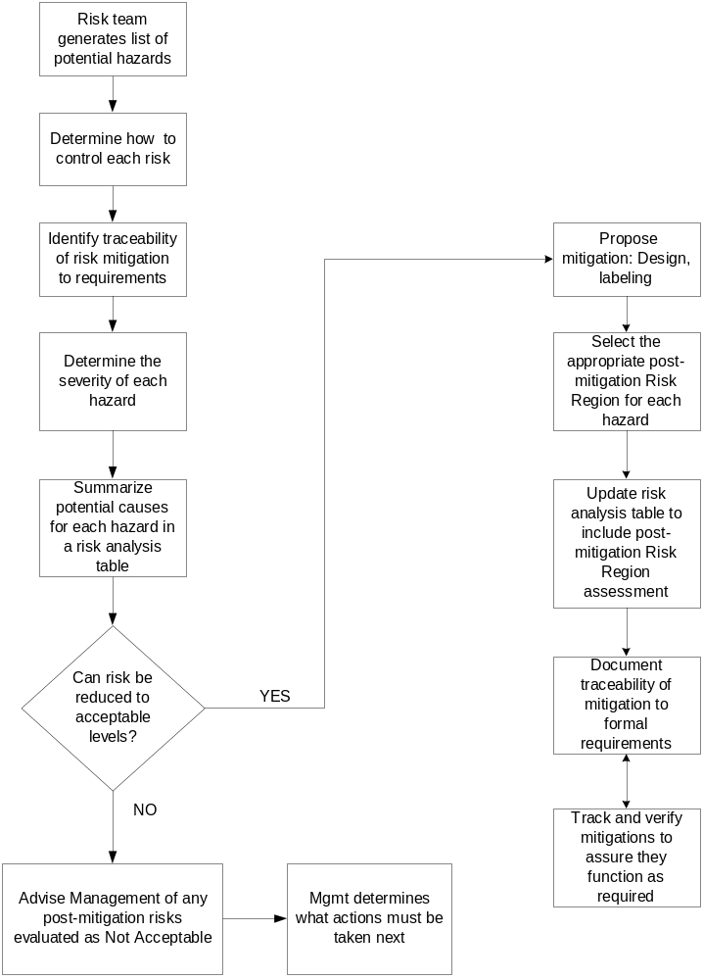

Section 1

Section 2

Document Approval
See the Document Control Process (DOC-0001) for the minimum set of approvers.
This document and its revisions are be approved by:
- Author
- President
- Chief Medical Officer

